A. Atomic structure: Model of the atom and structure of the atom
- Describe JJ. Thomson’s plum pudding model of the atom. (2)
Cloud of positive charge [1] with tiny negatively charged electrons spread throughout [1]

- State two ways in which Rutherford changed Thomson’s model of the atom. (3)
Positive charge [1] concentrated into very small volume at centre of atom (nucleus) [1] electrons orbit nucleus [1]

- Explain why Niels Bohr revised Rutherford’s model of the atom. (2)
Electrons gave out the same energies [1] as they moved from one energy level to another so they must be in electron shells/orbits [1]

- Explain how to calculate the numbers of protons, neutrons and electrons in an atom. (3)

The number of protons is the atomic number (1) This is the same as the number of electrons (1)
To calculate the number of neutrons you have to minus the atomic number from the mass number (1)

- Explain the overall charge on any atom. (2)
Neutral (1)
Same number of protons (+) and electrons (–) (1)
so charges cancel out (1)

- Explain how an atom can become an ion with a 2+ charge. (2)
Losing two electrons (1)
Two more positive charges than negative charges so overall charge is 2+ (1)

- Describe the differences in the atomic structures of a hydrogen atom and a helium atom. (3)
(Hydrogen has a mass number of 1 and atomic number of 1 and helium has a mass number of 4 and a mass number of 2).
Hydrogen has one proton whereas helium has two protons (1)
Hydrogen has one electron whereas helium has two electrons (1)
Hydrogen has no neutrons or helium has two neutrons (1)

B. Atomic structure: Isotopes and relative atomic mass
- Explain why isotopes of the same element have identical chemical properties. (2)
Same electronic structures [1] so same number of electrons in highest energy level / outermost shell [1]

- There are two principal stable isotopes of chlorine - ³⁵Cl and ³⁷Cl. The relative atomic mass of chlorine is 35.5. Explain what this shows about the abundance of the two isotopes. (2)
The relative atomic mass is a (weighted) average [1]
There must be more of chlorine–35 because the relative atomic mass is closer to 35 than 37 [1]

- Demonstrate that the relative atomic mass of a sample copper is 63.5 using the following information about the relative abundance of its isotopes: 30% Cu- 65; 70% Cu- 63. (2)
(30 x 65) + (70 x 63) = 63.6
100

- A sample of copper contains 30% Cu- 65 and 70% Cu- 63. Describe the structure of the two forms of copper and explain why, in this sample, boron has a relative atomic mass of 63.5. (6)
Structure of Cu-65: protons = 29; electrons = 29; neutrons = 36
Structure of Cu-63: protons = 29; electrons = 29; neutrons = 36
Relative atomic mass is 63.5 because: it is a weighted mean [1]; more Cu-63 than Cu-65 [1] Cu-63 are lighter [1]; therefore relative atomic mass is nearer 63 than 65 [1]

C. Periodic table: Mendeleev, atomic number, metals and non-metals and electronic configuration
- Explain how Dmitri Mendeleev constructed his periodic table. (2)
Arranged elements in order of atomic weight [1]
Started new rows to allow elements with similar properties to be in the same column/group [1]

- Explain how the scientific community were influenced to accept Dmitri Mendeleev’s version of the periodic table. (4)

Mendeleev predicted properties of ‘as yet undiscovered’ elements in gaps left in his table
so that similar elements would line up [1]

When new elements discovered [1]
they closely matched properties predicted [1]
this was powerful evidence Mendeleev’s table was valid [1]

- Explain how the position of an element in the periodic table is related to the arrangement of electrons in its atoms. (2)

The elements group is the same as the number of electrons in its highest energy level (1)

The period number indicates how many energy levels there are (1)

- Explain why elements in many groups of the periodic table have similar chemical properties. (1)
Same number of electrons in highest energy level / outermost shell [1]
- Group 4 elements contain a mixture of metals and non-metals. Explain, using its position in the periodic table, whether germanium is a metal or a non-metal. (2)
Metal [1] because it is below the metal/ non-metal dividing line [1]

- Element X is found in group 7 and period 2 in the periodic table. Use this information to predict its electron configuration and explain your working. (3)
2, 7 [1]
Group 7 so 7 electrons in outer shell [1]
Period 2 so 2 electron shells [1]
D. Ionic bonding
- Explain the charges on the following ions:

- Na⁺
Sodium has lost one electron

- O²⁻
Oxygen has gained two electrons

2. Sodium chloride NaCl and sodium oxide have ionic bonds.
- Draw dot and cross diagrams to show what happens to sodium and chlorine atoms when they react to form sodium chloride. You only need to show the outer electrons in your diagrams. (3)

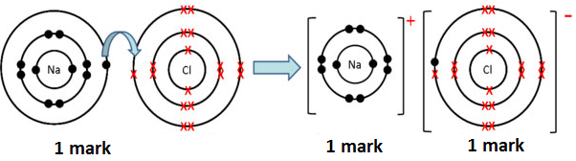

- Draw dot and cross diagrams to show what happens to sodium and oxygen atoms when they react to form sodium oxide. (3)

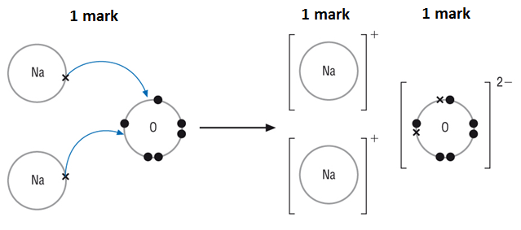

- Use your periodic table to calculate the numbers of protons, neutrons and electrons in the following ions:
  - Na⁺ (1)
11 protons; 12 neutrons; 10 electrons
  - O²⁻ (1)
8 protons; 8 neutrons; 10 electrons

- Explain the formation of ions from their atoms for Group 1 and 2 metals. (3)
Both form cations [1] Group 1 lose 1 electron becoming +1 ions [1] Group 2 lose 2 electrons becoming +2 ions [1]

- Explain the structure of the ionic compound sodium chloride. (5)
Lattice structure [1] regular arrangement of ions [1] alternating Na⁺ and Cl⁻ ions [1] held together by strong electrostatic forces [1] between oppositely charge ions [1]

- Deduce the formula for the following ionic compounds given the following formulae of their constituent ions: Ca²⁺; O²⁻; Mg²⁺; F⁻; Al³⁺
- Calcium oxide (1)
CaO
- Magnesium fluoride (1)
MgF₂
- Aluminum oxide (1)
Al₂O₃

E. Covalent bonding
- Explain how a covalent bond is formed. (4)
Occurs in non-metals [1] atoms share pairs [1] of electrons [1] strong bonds [1]

- Draw a diagram to represent the covalent bonding between two chlorine atoms. (2)
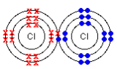
1 mark – correct number of electrons in outer shell
1 mark – one pair of shared electrons
(Accept diagram with outer shell only drawn)

- Why don’t simple molecular substances conduct electricity? (1)
There is no overall charge (1)

- Nitrogen gas has a very strong triple covalent bond holding the atoms together. Explain why nitrogen has a boiling point of -196°C. (2)
Molecules / weak intermolecular forces between N2 molecules, [1] so molecules easily separated from each other [1]

- Describe what is meant by intermolecular forces. (1)
The attraction between the individual molecules in a covalently bonded structure (1)
F. Properties of substances: Ionic substances, simple molecular compounds (covalent)
1. Explain why ionic compounds have high melting points and boiling points. (2)
Ionic bonds are very strong (1) a lot of energy is needed to break them (1)

2. Why can ionic compounds conduct electricity when they are molten or dissolved in water? (1)
Only conduct electricity if their ions are free to move such as when dissolved in water or melted (1)

3. Why is seawater a better conductor of electricity than freshwater? (1)
Higher concentration of ions from dissolved salts in seawater than in freshwater [1]

- Explain why oxygen has a low boiling point. (1)
Weak intermolecular forces/ weak forces of attraction between molecules [1]

- Explain the difference in the ability of solid sodium fluoride and molten sodium fluoride to conduct electricity in terms of their structures. (6)
Solid: does not conduct; regular arrangement; Na⁺ and F⁻ ions; strong ionic bonds; strong electrostatic attraction; between oppositely charged ions; ions cannot move
Molten: does conduct; strong ionic bonds/ electrostatic attraction broken by heat; ions can move
- Level 3 (5-6 marks)
Detailed explanation, including all main points, uses correct terminology e.g. electrostatic
- Level 2 (3-4 marks)
Simple explanation, including movement of ions, but not including information on attractions or bonds
- Level 1 (1-2 marks)
Limited explanation, including whether it does or does not conduct
G. Properties of substances: Diamond, graphite, graphene, fullerenes and polymers
- Graphite is sometimes used to reduce the friction between two surfaces that rub together. Explain how it does this. (2)
Graphite is made up of layers of carbon atoms, which can easily slide over each other (1). This means that graphite is slippery (1), making it a good lubricant.
- Extended response question:
Describe how the structures of diamond and graphite are similar and explain why graphite can conduct electricity, but diamond cannot. (6)
- Level 3 (5-6 marks)
Describes the similarities in the structures, why diamond cannot conduct electricity and why graphite can.
- Level 2 (3-4 marks)
L2 Describes the similarities in the structures AND why diamond cannot conduct electricity OR Describes the similarities in the structures AND why graphite can conduct electricity OR Describes why diamond cannot conduct electricity AND why graphite can.
- Level 1 (1-2 marks)
Describes the similarities in the structure OR, why diamond cannot conduct electricity OR why graphite can.

Chemistry points:

Similarities – giant structures/carbon atoms/covalent bonds

Graphite:
hexagons of C atoms arranged in layers,
each C atom forming three strong covalent bonds to its nearest neighbours,
as C atoms have 4 electrons in outer shell, this leaves one free outer electron on each,
free electrons drift freely along layers, enabling graphite to conduct electricity

Diamond:
all outer shell electrons involved in covalent bonding,
no free electrons carry electrical charge

- State which properties of graphene make it useful in the manufacture of bullet-proof vests. (2)
Flexibility [1] strength [1]

- Explain why graphene is such a good conductor of electricity. (5)
Atoms in each layer of graphene arranged in hexagons, [1] each C atom only forms three strong covalent bonds, [1] leaving one spare outer electron on each C atom [1] free to move along layer of C atoms, [1] these mobile delocalised electrons can drift along the layer conducting electricity [1]

- Ethene C₂H₄ can be polymerised to Poly(ethene).
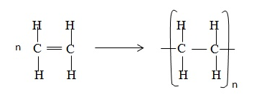
- Explain in terms of its structure why ethene is a gas at room temperature. (2)
Simple molecules/small molecules/weak intermolecular forces/weak attraction between molecules/little energy needed to break them (1) and therefore has a low boiling point (1)
- Explain in terms of its structure why poly(ethene) is a polymer. (2)
Long chained molecule (1) made from smaller repeating units (1)
- Explain why poly(ethene) has a high melting point. (1)
A lot of energy is needed to break the many bonds (in the long-chained molecule) (1)
H. Properties of substances: Metals and the limitations of models
- This diagram shows a model of metallic bonding:
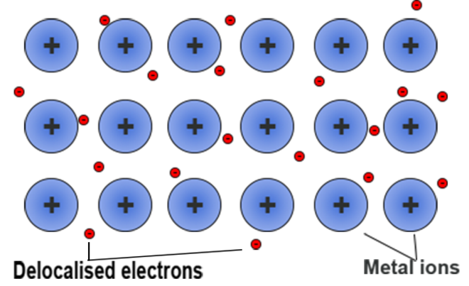
- Why are the particles that makeup a metal described as positively charged ions? (2)
Because metal atoms lose outer shell electrons [1] more protons (+) than electrons (−) [1]

- What are delocalised electrons? (2)
Free-moving electrons within structure, [1] not associated with a particular atom [1]

- Explain the bonding in a metal using the theory of metallic bonding. (4)
Electrons in metals outer shell, [1] donated into ‘sea’ of free-moving delocalised electrons, [1] electrostatic attraction [1] of negatively charged delocalised electrons for metals ions bonds
Ions in giant metallic lattice [1]

- Extended response question: Copper is a good metal for making a kettle because it has a high melting point. Explain why copper has a high melting point. You should describe the structure and bonding of a metal in your answer.
- Level 3 (5-6 marks)
Clear and detailed scientific description of why copper has a high melting point including details of the structure and bonding in a metal.
- Level 2 (3-4 marks)
A scientific description of why copper has a high melting point with some detail of the structure and bonding of metals.
- Level 1 (1-2 marks)
A brief description of the structure of a metal and why it has a high melting point.

Chemistry points:
- Giant structure/lattice/atoms arranged in a regular pattern or in layers
- Sea of electrons or delocalised electrons or free electrons
- Awareness that outer electrons are involved#
- Positive ions
- Electrostatic attraction/bond between electrons and positive ions
- Bond/attraction between atoms/ions/electrons are strong
- A lot of energy/heat is needed to break the bonds/attractions

- The following diagram shows a model of how ions are arranged in the ionic substance magnesium chloride. Explain the disadvantages of using this model to represent an ionic compound. (2)
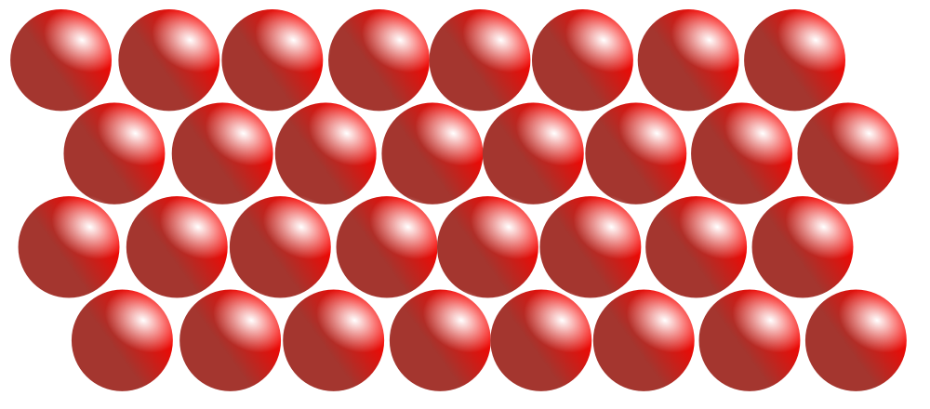
Particles same size/ should be different sizes [1] should represent the formula MgCl₂/ two chlorines per magnesium [1] model is 2D not 3D [1]
I. Calculations involving masses: Relative formula mass
- Calculate the relative formula mass of Na₂CO₃. (1)
106 (1)

- Calculate the relative formula mass of NH₄NO₃. (1)
80 (1)

- Calculate the relative atomic mass of Iron (with 5.8% ⁵⁴Fe, 91.8% ⁵⁶Fe, 2.1% ⁵⁷Fe and 0.3% ⁵⁹Fe). (2)

Ar of Fe = (5.8 × 54) + (91.8 × 56) + (2.1 × 57) + (0.3 × 58)/100 = 5591.1/100 = 55.9

J. Calculations involving masses: Empirical and molecular formulae
- Describe an experiment to determine the empirical formula of magnesium oxide. (6)
Experiment:
Find mass of empty crucible + lid
Find mass of magnesium ribbon
Heat magnesium in crucible, lift lid occasionally to allow oxygen in; do not allow loss of magnesium oxide
Cool, find mass of container, contents + lid
Repeat heating until constant mass
Calculation:
Mass magnesium oxide = mass crucible & lid at end – mass empty crucible & lid
Mass oxygen = mass magnesium oxide – mass magnesium ribbon
Mass ÷ RFM magnesium
Mass ÷ RFM oxygen
Ratio magnesium: oxygen
- Level 3 (5-6 marks)
Clear and detailed scientific description of experiment and calculation.
- Level 2 (3-4 marks)
- Clear and detailed scientific description of experiment.
- Level 1 (1-2 marks)
A brief description of the experiment or calculation.

- An oxide of lead was analysed by a chemist. 0.828g of lead was combined with 0.128g of oxygen in this sample. Calculate the empirical formula of this lead oxide. Relative atomic masses: O 16; P 207
0.828 ÷ 207 = 0.004; 0.128 ÷ 16 = 0.008 [1]
0.004:0.008 = 1:2 ratio [1]
PbO₂ [1]

- An experiment was conducted to determine the empirical formula of magnesium oxide.
  - Suggest why the lid of the crucible had to be raised occasionally during the heating process. (1)
To allow air/ oxygen in [1]

  - Write a balanced symbol equation for the reaction between magnesium and oxygen. (2)
2Mg + O₂ 2MgO formulae correct [1] balanced [1]

  - Deduce the empirical formula from the following results for the experiment. (3) Relative atomic masses: Mg 24; O 16
Mass of magnesium  used / g | Mass of magnesium oxide formed /g | Mass of oxygen in magnesium oxide /g
0.10 | 0.16 | 0.06
0.10 ÷ 24 = 0.004; 0.06 ÷ 16 = 0.004 [1]
Ratio 1:1 [1]
MgO [1]

K. Calculations involving masses: Conservation of mass
- Describe the law of conservation of mass. (1)
Mass products = mass reactants [1]

- During thermal decomposition of copper carbonate (CuCO₃) a student noticed the mass of the copper oxide formed was less than the mass of the copper carbonate at the start of the experiment. Explain, using an equation, why this reaction still follows the law of conservation of mass. (3)
CuCO_{3(s)} CuO_{(s)} + CO_{2(g)} [1]
A gas is formed during the reaction [1]
Mass of reactants = mass products when gas is included [1]
L. Calculations involving masses: Masses of reactants and products from balances equations; concentration of solution
- A technician made up a solution of sodium hydroxide by placing 5.00g of solid sodium hydroxide in a flask and adding 100cm³ of water. She placed in the stopper and shook until the reaction had stopped. What was the concentration of the solution in g/dm³? (1)
50 g/dm³ [1]

- A solution of copper chloride has a concentration of 300g/dm³. What is the mass of copper chloride in 500cm³ of the solution? (2)
500/1000 = 0.5 g/dm³ (1)
300g/dm³ x 0.5 = 150g (1)

- Higher: Explain how the mass of a solute and the volume of water effect the concentration of a solution. (2)

A greater mass of solute in a certain volume of water → more concentrated solution, [1]
greater volume of water for a certain mass of solute → less concentrated solution [1]

- How many moles of sulfur atoms are there in:
a) 9.8 grams of sulfur? (1)
0.3 moles (1)

b) 16 tonnes of sulfur? (where 1 tonne = 1000kg) (1)
500000 moles (1)

- What is the mass of:
a) 0.04 moles of hydrogen H₂? (1)
0.04 x 2 (1x2) = 0.08g (1)

b) 0.6 moles of sodium nitrate (NaNO₃)? (2)
23 + 14 + (16x3) = 85 (1)
0.6x 85 = 51g (1)

- When calcium reacts with water it forms a solution of calcium hydroxide Ca(OH)₂ and hydrogen gas.
- Write a balanced symbol equation, including the state symbols to show this equation. (3)

Ca(s) + 2H₂O(l) → Ca(OH)₂(aq) + H₂(g)
1 mark for symbols, 1 mark for balancing and 1 mark for state symbols

- Calculate how much calcium must be added to an excess of water to produce 3.7g of calcium hydroxide. (2)
2.0g (2)

- What mass of sodium chloride is produced when 5.3g of sodium carbonate reacts with excess dilute hydrochloric acid? (3)

Na₂CO₃ + 2HCl → 2NaCl + H₂0 + CO₂

Mr of sodium carbonate = (23x2) +12+(16x3) = 106 [1]

Mr of sodium chloride = 23+35.5 = 58.5 x 2 = 117 [1]

Ratio of sodium chloride to sodium carbonate 117/106

Mass of sodium chloride 5.3 x 117/106 = 5.85g [1]

- 84 tonnes of nitrogen were mixed with 30 tonnes of hydrogen in the following equation:

N₂(g) + 3H₂(g) 2NH₃(g)

- Calculate the number of moles of nitrogen and hydrogen and calculate which reactant is the limiting factor. (3)
3,000,000 moles of nitrogen (1)
15,000,000 moles of hydrogen (1)
(using the 1:3 ratio of N2 (g) + 3 H2 (g)) we need 5,000,000 moles of N2 therefore it is the limiting reactant (1)

- Calculate the maximum mass of ammonia that can be produced from 42 tonnes of nitrogen. (3)
51 tonnes
correct answer with or without working scores 3 marks
if the answer is incorrect award up to 2 marks for the working
3,000,000 moles of N₂ will give 6,000,000 moles of NH3

M_{r} NH3 = 17

M. Calculations involving masses: Moles and stoichiometry
- What is meant by the term ‘Avogadro constant’? Include a value for the constant in your response. (2)
One mole of particles of a substance [1] 6.02 x 10²³ [1]

- How many atoms of carbon would be found in 10g? (2)
Moles = mass ÷ RAM = 10 ÷ 12 = 0.83 [1]
Number = moles x Avogadro constant = 0.83 x 6.02 x 10²³ = 5.0 x 10²³ [1]

- How many moles are there in 42g of carbon? (1)
Moles = mass ÷ RAM = 42 ÷ 12 = 3.5 [1]

- Explain why, in a reaction, the mass of the product formed is controlled by the mass of the reactant not in excess. (3)
The reactant in excess has more present than needed for the reaction/ some will be left when the reaction completed [1]
The reactant used up is the limiting reactant [1]
Maximum amount reactant in excess that reacts = exact amount that will react with all the available limiting reactant [1]
- 0.010 moles of C₄H₁₀ reacts with oxygen as in the following equation:

C₄H₁₀ + O₂ → ___CO₂ + ___H₂0

1.76g of carbon dioxide and 0.90 of water are produced.
Use this information to work out the balancing numbers for carbon dioxide and water. (4)

4 CO₂ and 5 H₂O

Correct answer with or without working scores 4 marks

If the answer is incorrect award up to 3 marks for the working

Mr CO₂ = 44 and Mr H₂O = 18 (1)
moles CO₂ = 0.040 (1)
moles H₂O = 0.050 (1)

